

UML class diagram
Author: OOPeraTeam
Date: 2024-12-22

UML class diagram (Model)
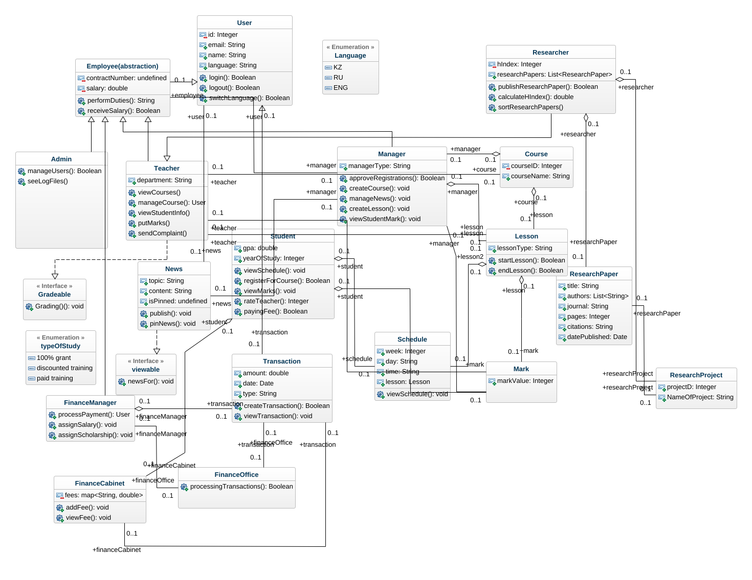
class-diagram

1. Admin (Class)
In UML class diagram
Extends
- Employee(abstraction) - see definition
Implements
- Gradeable - see definition
Operations
manageUsers : Boolean
seeLogFiles

2. Course (Class)
In UML class diagram
Attributes
courseID : Integer [1]
courseName : String [1]
Associations
Teacher_Course - teacher : Teacher [0..1] - see definition
Course_Lesson - lesson : Lesson [0..1] - see definition
Course_Manager - manager : Manager [0..1] - see definition

3. DataType (DataType)
In UML class diagram

4. DataType2 (DataType)
In UML class diagram

5. DataType3 (DataType)
In UML class diagram

6. Date (DataType)
In UML class diagram

7. Employee(abstraction) (Class)
In UML class diagram
Extends
- User - see definition
Attributes
contractNumber : invalid [1]
salary : double [1]
Operations
performDuties : String
receiveSalary : Boolean
Associations
Employee_Manager - manager : Manager [0..1] - see definition

8. Enumeration (Enumeration)
In UML class diagram

9. FinanceCabinet (Class)
In UML class diagram
Attributes
fees : map<String, double> [1]
attribute : invalid [1]
Operations
addFee : void
viewFee : void
Associations
Transaction_FinanceCabinet - transaction : Transaction [0..1] - see definition
Student_FinanceCabinet - student : Student [0..1] - see definition

10. FinanceManager (Class)
In UML class diagram
Extends
- Employee(abstraction) - see definition
Operations
processPayment : User
assignSalary : void
assignScholarship : void
Associations
FinanceManager_FinanceOffice - financeOffice : FinanceOffice [0..1] - see definition
FinanceManager_Transaction - transaction : Transaction [0..1] - see definition

11. FinanceOffice (Class)
In UML class diagram
Operations
processingTransactions : Boolean
Associations
FinanceManager_FinanceOffice - financeManager : FinanceManager [0..1] - see definition
Transaction_FinanceOffice - transaction : Transaction [0..1] - see definition

12. Gradeable (Interface)
In UML class diagram
Operations
Grading() : void
subjectTaught : void

13. Language (Enumeration)
In UML class diagram
- KZ
- RU
- ENG

14. Lesson (DataType)
In UML class diagram

15. Lesson (Class)
In UML class diagram
Attributes
lessonType : String [1]
Operations
startLesson : Boolean
endLesson : Boolean
Associations
Manager_Lesson - manager : Manager [0..1] - see definition
Course_Lesson - course : Course [0..1] - see definition
Lesson_Schedule - schedule : Schedule [0..1] - see definition
Lesson_Mark - mark : Mark [0..1] - see definition
Teacher_Lesson - teacher : Teacher [0..1] - see definition

16. List<ResearchPaper> (DataType)
In UML class diagram

17. List<String> (DataType)
In UML class diagram

18. Manager (Class)
In UML class diagram
Extends
- Employee(abstraction) - see definition
Attributes
managerType : String [1]
Operations
approveRegistrations : Boolean
createCourse : void
assignCourse : Boolean
generateReport : Boolean
manageNews : void
createLesson : void
viewStudentMark : void
Associations
Course_Manager - course : Course [0..1] - see definition
Manager_News - news : News [0..1] - see definition
Manager_Mark - mark : Mark [0..1] - see definition
Employee_Manager - employee : Employee(abstraction) [0..1] - see definition
Manager_Lesson - lesson : Lesson [0..1] - see definition

19. Mark (Class)
In UML class diagram
Attributes
markValue : Integer [1]
Associations
Teacher_Mark - teacher : Teacher [0..1] - see definition
Lesson_Mark - lesson : Lesson [0..1] - see definition
Student_Mark - student : Student [0..1] - see definition
Manager_Mark - manager : Manager [0..1] - see definition

20. Message (Class)
In UML class diagram
Attributes
messageId : Integer [1]
Operations
send : Boolean
delete : Boolean
Associations
User_Message - user : User [0..1] - see definition

21. News (Class)
In UML class diagram
Implements
- viewable - see definition
Attributes
topic : String [1]
content : String [1]
isPinned : invalid [1]
Operations
publish : void
pinNews : void
Associations
Manager_News - manager : Manager [0..1] - see definition
News_User - user : User [0..1] - see definition

22. ResearchPaper (Class)
In UML class diagram
Attributes
title : String [1]
authors : List<String> [1]
journal : String [1]
pages : Integer [1]
citations : String [1]
datePublished : Date [1]
Associations
ResearchProject_ResearchPaper - researchProject : ResearchProject [0..1] - see definition
Researcher_ResearchPaper - researcher : Researcher [0..1] - see definition

23. ResearchProject (Class)
In UML class diagram
Attributes
projectD : Integer [1]
NameOfProject : String [1]
Associations
ResearchProject_ResearchPaper - researchPaper : ResearchPaper [0..1] - see definition
Researcher_ResearchProject - researcher : Researcher [0..1] - see definition

24. Researcher (Class)
In UML class diagram
Extends
- Teacher - see definition
Attributes
hIndex : Integer [1]
researchPapers : List<ResearchPaper> [1]
Operations
publishResearchPaper : Boolean
calculateHIndex : double
sortResearchPapers
Associations
Researcher_ResearchProject - researchProject : ResearchProject [0..1] - see definition
Researcher_ResearchPaper - researchPaper : ResearchPaper [0..1] - see definition

25. Schedule (Class)
In UML class diagram
Attributes
week : Integer [1]
day : String [1]
time : String [1]
lesson : Lesson [1]
Operations
viewSchedule : void
Associations
Lesson_Schedule - lesson2 : Lesson [0..1] - see definition
Student_Schedule - student : Student [0..1] - see definition

26. Student (Class)
In UML class diagram
Extends
- User - see definition
Attributes
gpa : double [1]
yearOfStudy : Integer [1]
Operations
viewSchedule : void
registerForCourse : Boolean
viewMarks : void
rateTeacher : Integer
payingFee : Boolean
payingForStudy : Boolean
Associations
Student_Schedule - schedule : Schedule [0..1] - see definition
Student_Mark - mark : Mark [0..1] - see definition
Student_FinanceCabinet - financeCabinet : FinanceCabinet [0..1] - see definition

27. Teacher (Class)
In UML class diagram
Extends
- Employee(abstraction) - see definition
Implements
- Gradeable - see definition
Attributes
department : String [1]
Operations
viewCourses
manageCourse : User
viewStudentInfo
putMarks
sendComplaint
Associations
Teacher_Lesson - lesson : Lesson [0..1] - see definition
Teacher_Course - course : Course [0..1] - see definition
Teacher_Mark - mark : Mark [0..1] - see definition

28. Teacher2 (Enumeration)
In UML class diagram

29. TeacherType (Enumeration)
In UML class diagram

30. Transaction (Class)
In UML class diagram
Attributes
amount : double [1]
date : Date [1]
type : String [1]
Operations
createTransaction : Boolean
viewTransaction : void
Associations
FinanceManager_Transaction - financeManager : FinanceManager [0..1] - see definition
Transaction_User - user : User [0..1] - see definition
Transaction_FinanceOffice - financeOffice : FinanceOffice [0..1] - see definition
Transaction_FinanceCabinet - financeCabinet : FinanceCabinet [0..1] - see definition

31. User (Class)
In UML class diagram
Attributes
id : Integer [1]
email : String [1]
name : String [1]
language : String [1]
Operations
login : Boolean
logout : Boolean
switchLanguage : Boolean
Associations
News_User - news : News [0..1] - see definition
User_Message - message : Message [0..1] - see definition
Transaction_User - transaction : Transaction [0..1] - see definition

32. double (DataType)
In UML class diagram

33. list (DataType)
In UML class diagram

34. list (DataType)
In UML class diagram

35. map<String, double> (DataType)
In UML class diagram

36. typeOfStudy (Enumeration)
In UML class diagram
- 100% grant
- discounted training
- paid training

37. viewable (Interface)
In UML class diagram
Operations
newsFor : void

38. void (DataType)
In UML class diagram

